|  |
| --- |
| Circle Language Spec: Execution Control |

## For Each in a Diagram

The concept of the For Each statement is already covered by the article *For Each*. This article only explains its expression in a diagram.

Below is an example of the diagrammatic expression of a For Each statement.

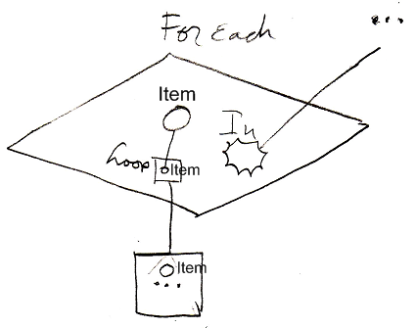

The diamond is a call to the For Each command. There is a nonagon called In visible inside the diamond. The In parameter can point to any collection to loop through.

The diamond contains a circle, named Item, which will hold the current item of the collection. The current item is passed to the Loop procedure, that will be run multiple times. The Loop procedure is displayed inside the diamond, as a square named Loop. The Loop procedure is *defined* outside the diamond. The Loop parameter inside the diamond, points out of the diamond to the larger square just below the diamond, with the ellipsis in it. The ellipsis stands for whatever you fill into it. The larger square below the diamond defines the command that will run multiple times, once for each item in the collection. The circle inside the large square is the Item passed to the Loop procedure. That circle is not tied to the Item parameter inside the For call, but it is implicitly connected to it, because of the connection between the squares that contain the circles.

(This is due to the rule of *implicit connection through parent.* See the article *Automatic Containment*.) Officially, the two smaller circles explicitly have to be named Item as well, to not confuse the circles with any other possible circles, that might be defined in the Loop.

In other loops, the Loop parameter was surrounded by an esteatic nonagon, but because the In parameter is already a nonagon, it is already obvious, that the command handles a collection, so a nonagon is not also placed around the Loop parameter.

In the example above, the In collection and the Loop procedure reference were defined outside the diamond. They may as well have been defined right inside the diamond. The diagram above is just an example

The *definition* of the For Each execution control command is part of a system module for execution control commands. The public elements of the definition look like this:

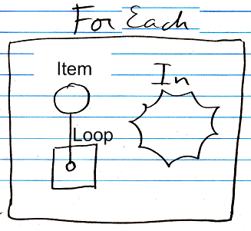

Nothing is filled in yet as the In collection or the Loop procedure reference. The Item parameter will be controlled by the For command. It is referenced from the Loop procedure.